EXP. NO:  6 | GENERATION AND ANALYSIS OF FREQUENCY MODULATED (FM) AND OF PHASE MODULATED (PM) SIGNALS USING MATLAB
DATE:

Objectives:
To generate and analyze Frequency Modulated (FM) and Phase Modulated (PM) signals using MATLAB by varying the instantaneous frequency and phase of a carrier signal in accordance with the message signal.
Procedure
1. Open MATLAB and create a new script file.
2. Define the simulation parameters, including the sampling frequency, time vector, message frequency, carrier frequency, message amplitude, and carrier amplitude.
3. Generate the message signal using a low-frequency sinusoidal waveform.
4. Generate the carrier signal using a high-frequency sinusoidal waveform.
5. Generate the Frequency Modulated (FM) signal by varying the instantaneous frequency of the carrier in accordance with the message signal and the selected frequency modulation index. 6. Generate the Phase Modulated (PM) signal by varying the instantaneous phase of the carrier according to the message signal and the selected phase modulation index.
7. Plot the message signal, carrier signal, FM signal, and PM signal using MATLAB subplots. 8. Observe and compare the time-domain waveforms of the FM and PM signals with the original message signal.
9. Analyze the variation in the instantaneous frequency of the FM signal and the instantaneous phase of the PM signal due to changes in the message signal.
10. Compare the characteristics of FM and PM signals by studying their modulation behavior and waveform variations.
11. Verify the successful generation of FM and PM signals based on the simulation results.
PROGRAM (MATLAB CODE) :
OBJECTIVE1:

%% EXP 6 - Objective 1: FM Signal Generation & Analysis
clc;
clear;
close all;

% Parameters
Am = 1; % Modulating signal amplitude (V)
Ac = 1; % Carrier amplitude (V)
fm = 5; % Message frequency (Hz)
fc = 50; % Carrier frequency (Hz)
beta = 5; % Modulation index
fs = 1000; % Sampling frequency (Hz)
t = 0:1/fs:1; % Time vector (1 second duration)

% Signals
m = Am * cos(2 * pi * fm * t); % Message signal
c = Ac * cos(2 * pi * fc * t); % Carrier signal
fm_sig = Ac * cos(2 * pi * fc * t + beta * sin(2 * pi * fm * t)); % FM signal

% Frequency Deviation Calculation
delta_f = beta * fm; % Peak frequency deviation (Hz)

% Display Results
fprintf('--- Objective 1: FM Analysis ---\n');
fprintf('Carrier Frequency (fc) : %d Hz\n', fc);
fprintf('Message Frequency (fm) : %d Hz\n', fm);
fprintf('Modulation Index (Beta) : %d\n', beta);
fprintf('Frequency Deviation (Delta f) : %d Hz\n', delta_f);

% Plotting
figure('Name', 'Objective 1: FM Generation', 'NumberTitle', 'off');

subplot(3,1,1);
plot(t, m, 'LineWidth', 1.2);
title('1. Modulating Message Signal m(t)');
xlabel('Time (s)'); ylabel('Amplitude (V)');
grid on;

subplot(3,1,2);
plot(t, c, 'LineWidth', 1.1);
title('2. Carrier Signal c(t)');
xlabel('Time (s)'); ylabel('Amplitude (V)');
grid on;

subplot(3,1,3);
plot(t, fm_sig, 'r', 'LineWidth', 1.1);
title('3. Frequency Modulated (FM) Signal');
xlabel('Time (s)'); ylabel('Amplitude (V)');
grid on;
OBJECTIVE2:

%% EXP 6 - Objective 2: PM Signal Generation & Comparison with FM
clc;
clear;
close all;

% Parameters
Am = 1;
Ac = 1;
fm = 5;
fc = 50;
beta = 5; % FM modulation index
kp = 5; % Phase sensitivity constant (rad/V)
fs = 1000;
t = 0:1/fs:1;

% Signal Generation
m = Am * cos(2 * pi * fm * t); % Message signal
c = Ac * cos(2 * pi * fc * t); % Carrier signal
fm_sig = Ac * cos(2 * pi * fc * t + beta * sin(2 * pi * fm * t)); % FM signal
pm_sig = Ac * cos(2 * pi * fc * t + kp * m); % PM signal

% Display
fprintf('--- Objective 2: PM Analysis & Comparison ---\n');
fprintf('Phase Sensitivity (kp) : %d rad/V\n', kp);
fprintf('Maximum Phase Deviation : %d radians\n', kp * Am);
fprintf('Comparison: FM instantaneous phase integrates m(t), while PM tracks m(t) directly.\n');

% Plotting Complete Comparison
figure('Name', 'Objective 2: FM vs PM Comparison', 'NumberTitle', 'off');

subplot(4,1,1);
plot(t, m, 'LineWidth', 1.2);
title('1. Modulating Message Signal');
xlabel('Time (s)'); ylabel('Amplitude');
grid on;

subplot(4,1,2);
plot(t, c, 'LineWidth', 1.1);
title('2. Carrier Signal');
xlabel('Time (s)'); ylabel('Amplitude');
grid on;

subplot(4,1,3);
plot(t, fm_sig, 'b', 'LineWidth', 1.1);
title('3. Frequency Modulated (FM) Signal');
xlabel('Time (s)'); ylabel('Amplitude');
grid on;

subplot(4,1,4);
plot(t, pm_sig, 'm', 'LineWidth', 1.1);
title('4. Phase Modulated (PM) Signal');
xlabel('Time (s)'); ylabel('Amplitude');
grid on;
OUTPUT :
O1: 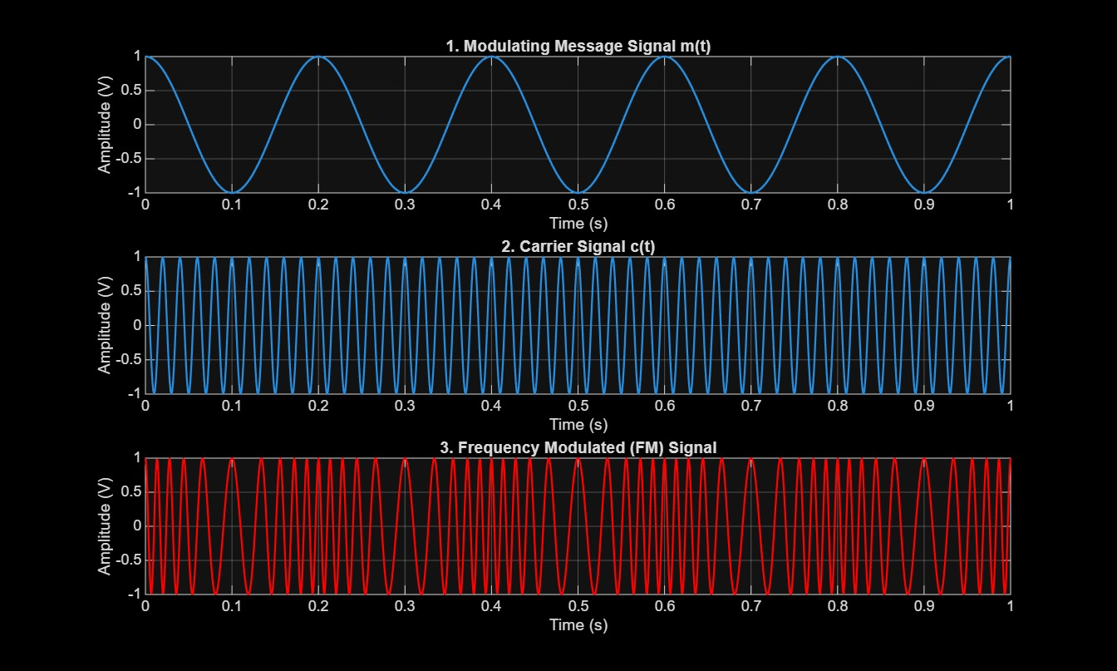
O2: 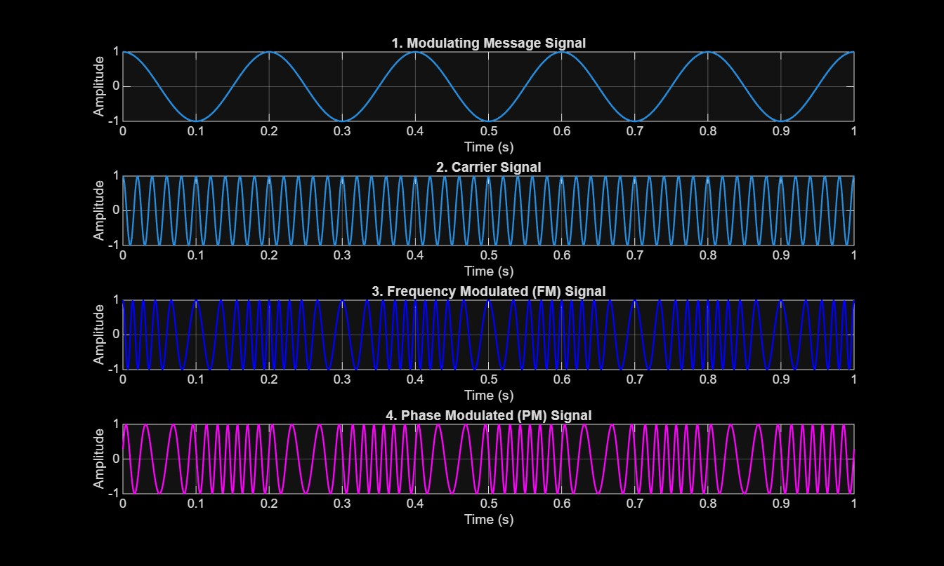
RESULT:
The Frequency Modulated (FM) and Phase Modulated (PM) signals were successfully generated using MATLAB by varying the instantaneous frequency and phase of the carrier signal according to the message signal.
• Frequency Deviation (Δf) = 25 Hz
• FM Modulation Index (β) = 5

